This document outlines the requirements to complete the Trade Partner Access Request (TPAR) form.
TPAR is a facility for users to gain access to specific LCBO systems. When completing this form, please note the following access levels and only apply to systems that apply to you company status.
New Agents can apply for New Item Submission System (NISS).
- When applying to NISS new leave company number field blank on the application form.
Existing Agents can apply for In-Store Programs, NISS, and Promotion Tracking (MPTS).
- When applying to these systems, you must have a LCBO company number.
Existing Suppliers can apply for WebPO, NISS (read-only), and Inbound Scheduling (local direct warehouse delivery).
- When applying to these systems, you must have a LCBO supplier number. Please contact your agent representation if you do not have your LCBO supplier number or the appropriate LCBO Business Unit. The Supplier Number is also located in the left corner of the purchase order form under Payment Terms
- Inbound Scheduling is only available for approved domestic vendors to deliver directly to a LCBO warehouse.

How to complete the form:
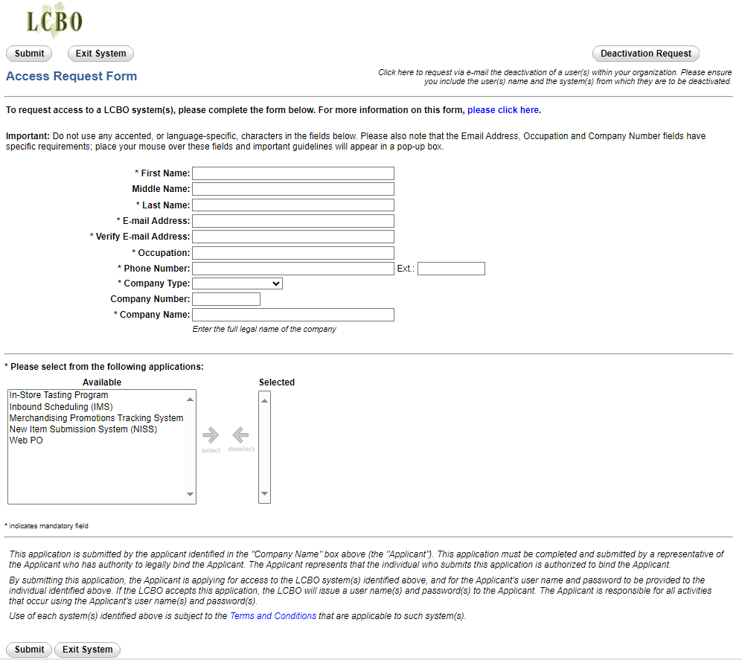
Important: Do not use any accented, or language-specific, characters in the fields below.

First and Last Name: The name of the applicant who is applying for access. This person has the company’s necessary authority to carry out the required transactions within each of the selected systems and who can legally bind the company.

Email Address: A unique email address where the applicant will receive login credentials and other information. This email address is not shared by more than one person in the company. This email address must contain the name of the person applying, as well as the company name.

Occupation: Job title of the applicant and ensuring they have legally authority to bind the company.

Company Type: See above for which company type has access to LCBO Systems.

Company Number: The LCBO assigned supplier or company (agent) number.

Company Name: The legal name of the company.
Selecting Applications:

When selecting the applications, refer to the guide above to choose the application available to each company type/status. New Agents, Existing Agents and Suppliers have different access to applications.
Use the Select arrow to add the application(s) to the Selected Column.
Select the “Submit” button to submit the application.

Frequently Asked Questions

How long does the access requests approval process take?
An email will be sent to the address provided with the access information within 1-5 business days after submitting the access request form on Trading Partner Access Request (TPAR).

Promotions Tracking and Instore Programs applications are located through the agent lcbonet.ca portal and are accessible within 1-2 days after the application is approved.

New Item Submission, WebPO, and Inbound Scheduling require account set up and may take up to 5 business days to complete. An email will be sent to the applicant with their login credential.

Can I apply for access on TPAR on behalf of other individuals?
No. Each LCBO system has specific legal terms and conditions with regards to applying for access.
Who applies for access to the WEB PO System?
Suppliers must apply for access to WEBPO. The person who applies for access acts as the authorized representative of their company. This representative must be able to discern the type of access they assign to users. Read‐write access is only assigned to users within your company who can legally bind the Supplier and execute agreements on behalf of the Supplier with regards to Purchase Orders. By designating an authorized representative as an Administrator for the new WEB PO System, a Supplier expressly consents to execute agreements solely by electronic transmission.
How do I know that my access request has been submitted successfully?
A receive a confirmation number will display on the screen once the application is submitted. Please print or save this for your records.

Where do I find information on the other systems listed in TPAR?
The applications are listed in the menu section under ONLINE TOOLS/SYSTEMS/FORM on the trade partner website www.doingbusinesswithlcbo.com.

Online tools/systems/Forms | Doing Business with LCBO, or click on each application below.

- New Item Submission (NISS)
- Web Purchase Order System (WEBPO)
- Inbound Scheduling (IMS) Web System
- Merchandising Promotion Tracking System (MPTS)

What does the company number refer to on the TPAR form?
Company Number refers to the Supplier, Agent, Freight Forwarder or Carrier number. Company numbers are only provided once the LCBO decides to do business with you.

How do I correct an error in TPAR after the form was submitted?
If an Access Request form was submitted with errors, a new access form is required. The previously submitted is not accessible for revision.

What is the official language of correspondence at LCBO?
The language of business at LCBO is English. If needed, translation services are available online, e.g. http://babelfish.yahoo.com/; http://worldlingo.com; www.free‐translator.com/

What LCBO web-system do I use to reply to Letters of Commitment?
The NISS system is used to reply to Letters of Commitment (LOCs).

For the NISS application process, an Agent can reply on behalf of the Supplier once a 'Delegation' letter is completed, signed, and mailed to the appropriate LCBO Business Unit. A template of the “Delegation” letter will be available on the Trade Resources Website.

Technical Support
The following is list of contacts where access has been granted to applications and require technical support.

WEBPO
Phone: 1-866-284-8311 or 1-866-616-9019
Email: Techsupport@lcbosupport.com
Web PO Access support
tpar@lcbo.com
Purchase Orders support
lcboorders@lcbo.com

NISS and Inbound Scheduling (IMS)
Phone: 1-866-284-8311 or 1-866-616-9019
Email: Techsupport@lcbosupport.com

Promotion Tracking (MPTS)
LCBO Technical support: 416-864-2550
Email: ITSrvDsk@lcbo.com

