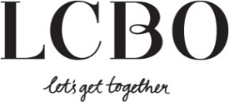
Quote Submission Form – How to Guide
This form is only used for Quote submissions for existing LCBO Wines, Spirits, Imported Beer, Cider & RTD, and Vintages Essentials.
Vintages quotes and revised quotes for new LCBO products should continue to be sent directly to the appropriate buying Category and quotes for private orders should continue to be sent to Specialty Services using existing forms and processes. Ontario Domestic Beer quotes should continue to be sent on the Beer Submission Form.
FORM LAYOUT
- The submission form is comprised of 5 tabs including:
  - Quote Template – This tab must be used for all quote price change submissions.
    - Domestic (Ontario) and Import (including other Canadian provinces) SKUs cannot appear on the same quote submission form. A separate quote submission form must be submitted.
  - Instructions – how to use the form, what to fill out, rules/regulations, contact information, important links
  - Sample – Sample quote submission for your review
  - Helpful Links – links to the specific web pages and email address

FILLING OUT THE SUBMISSION FORM

- It is important to note that all applicable fields in MUST be filled out correctly to enable the LCBO to process your price change request (see yellow highlights below). If the required fields are not filled out your submission can be declined.
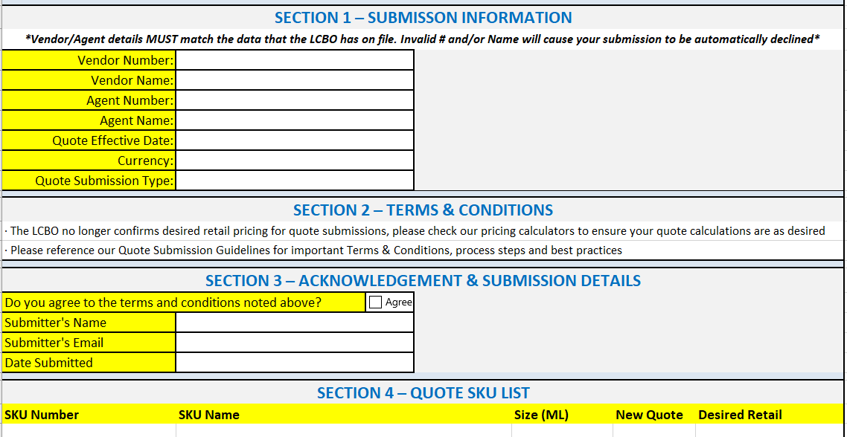
- SECTION 1 – SUBMISSION INFORMATION
All fields highlighted in yellow MUST be filled in correctly to ensure follow up communications are sent to the correct contact and pricing is made effective for the correct day.
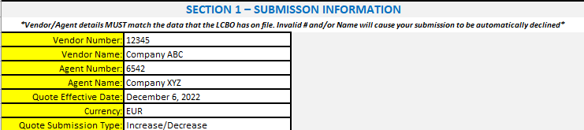
    - VENDOR NUMBER - The vendor number assigned by the LCBO to the vendor(supplier).
    - VENDOR NAME - The vendor’s name that is set up with LCBO for the vendor.
    - AGENT NUMBER- The agent number assigned by the LCBO to the vendor agent representative.
    - AGENT NAME – The agent’s name that is set up with the LCBO for the vendor agent representative.
    - QUOTE EFFECTIVE DATE - Date the quote is to take effect on new purchase orders.
    - CURRENCY – the payment currency of the vendor quote.
    - QUOTE SUBMISSION TYPE - Choose from list
- Increase/Decrease - for quote changes as per the quote submission schedule for orders issued (by LCBO Financial Period), as well for Weekly Beer Submissions
- Immediate Decrease - will take effect immediately on next purchase order (but will not impact current orders/inventory)
- LAFR - response in changing the quote because of the change in freight rates

- SECTION 2 – TERMS & CONDITIONS

- SECTION 3 – ACKNOWLEDGEMENT & SUBMISSION DETAILS
All fields highlighted in yellow MUST be completed.
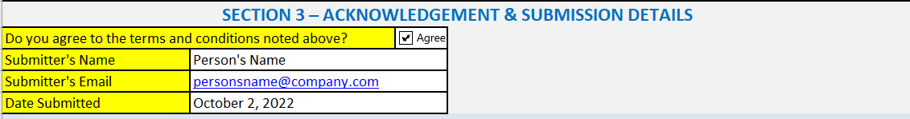
    - DO YOU AGREE TO THE TERMS AND CONDITIONS NOTED ABOVE – MUST be checked to proceed with changing the quote prices.
    - SUBMITTER’S NAME – the person representing the vendor that is completing and authorizing the quote change.
    - SUBMITTER’S EMAIL – the email of the person named in Submitter’s Name
    - DATE SUBMITTED - the date the quote submission template was sent to pricing@lcbo.com

- SECTION 4 – QUOTE SKU LIST
The SKU data fields MUST be filled in full.
Please note the following -

    - SKU NUMBERS - The LCBO SKU number must be populated if the SKUs are currently sold to the LCBO. The following scenarios apply:
      - If your SKU is exclusive to LCBO (Grocery & Convenience) then provide your 6-digit LCBO SKU number (SKU number can be up to 6-digits long)
    - SKU NAME - The SKU name should be filled in using the name currently appearing on a store bin tag or signage.
    - SIZE (ML) - Selling Unit size – total ml sold per unit (500ml, 473ml, etc.)
    - New Quote – Vendor purchase price per case. This is the price the LCBO will pay the vendor for the product.
    - Desired Retail - Provide the full customer facing desired retail price. This is the price which will be inclusive of all taxes, fees, deposits, etc. and will be visible “on shelf” to customers. *TIP* the new retail rounded price must be rounded to the nearest 5 cent increment such as 9.95, 10.00, 10.05*

HELPFUL TIPS
- For domestic beer & TBS beer price change submissions please continue to use the Beer Submission Form located on DoingBusinesswithLCBO.com and send completed forms to pricing@lcbo.com by 4pm on Monday. Include in the subject line "Beer Pricing – Brewer name, effective date". Retail prices submitted by 4pm will be effective two weeks later on Monday in the appropriate retail channels. Any submission received AFTER 4pm will be processed in the following week.
- For TBS/LCBO imported combo sku price changes please continue to send the beer submission form and the new quote submission form.
- “Do not include pricing on the submission form for SKUs on LCBO LTO which have been approved in the Merchandise Promotion Tracking System (MPTS). The LCBO will update the promotional pricing automatically when the SKUs go on and off LTO at the beginning of each period. Please note, you can include a price change for a product coming off LTO once the LTO ends.
- DO NOT MANIPULATE OR CHANGE THE FORMATTING OF THIS FORM. CHANGING THE FORMATTING ON THIS FROM CAN RESULT IN DECLINED SUBMISSIONS
- Quote submissions for existing LCBO Wines, Spirits, Beer, Cider & RTD, and Vintages Essentials products must be sent to pricing@lcbo.com.
- Quotes increases will be posted in accordance with the LCBO Schedule of Quote Increases posting timelines unless otherwise noted or agreed upon. Requests for quote decreases or rebates may be submitted at any time, however this must be clearly stated in the subject line and body of the e-mail. For Example: “Quote Decrease – ABC Beverage Co”, or “Rebate – ABC Beverage Co”. Implementation is subject to approval from the appropriate Category or Product Manager. All rebates are subject to Category approval; thus, we strongly recommend you discuss your plans for SKU rebates ahead of time with your appropriate Category or Product Manager.
- Quote increases may not be accepted if they fail to meet LCBO pricing policies regarding changes in quotes (e.g., listed less than one-year, excessive increases, period promotions).
- Quote submissions are only accepted by email and must be sent from the vendor, or agent’s company email account.
- Quote submissions must be submitted using the LCBO Quote Submission Form. The form must be completed in full, and formatting not manipulated. Manipulating of this form could result in the submission being declined, or errors with inputting of quote data.
- When submitting to pricing@lcbo.com, send individual e-mails for each unique vendor submission. The subject of the email must be in this format: QUOTE – Vendor Name. For example: “Quote – ABC Beverage Co.” If multiple vendors are referenced in the same e-mail, each vendor MUST be listed in the body of the e-mail.
- LCBO’s Pricing Administration team will NOT accept combining of multiple vendors on a submission form. One vendor quote(s) per submission form is required.
- Please ensure quote submissions are for active code 2 listed LCBO SKUs – we do not post quotes for delisted SKUs.
- Please be mindful and plan for upcoming LCBO approved promotional programming when providing requotes, as prices cannot change for one period before a planned promotion.
- Vintages non-essential quotes and revised quotes for new LCBO products should continue to be sent directly to the appropriate buying Category using existing forms and processes.
- Quotes for private orders should continue to be sent to Specialty Services using existing forms and processes.
- Ontario Domestic Beer quotes should continue to be sent on the Beer Submission Form.
- The LCBO is not responsible for any errors or omissions made in the vendor’s Quote Submission Form. Failure to meet deadlines or LCBO pricing policies may result in postponement of quote increases.

